**Lesson Outline**

**1. Odometers, Speedometers, and Derivatives**

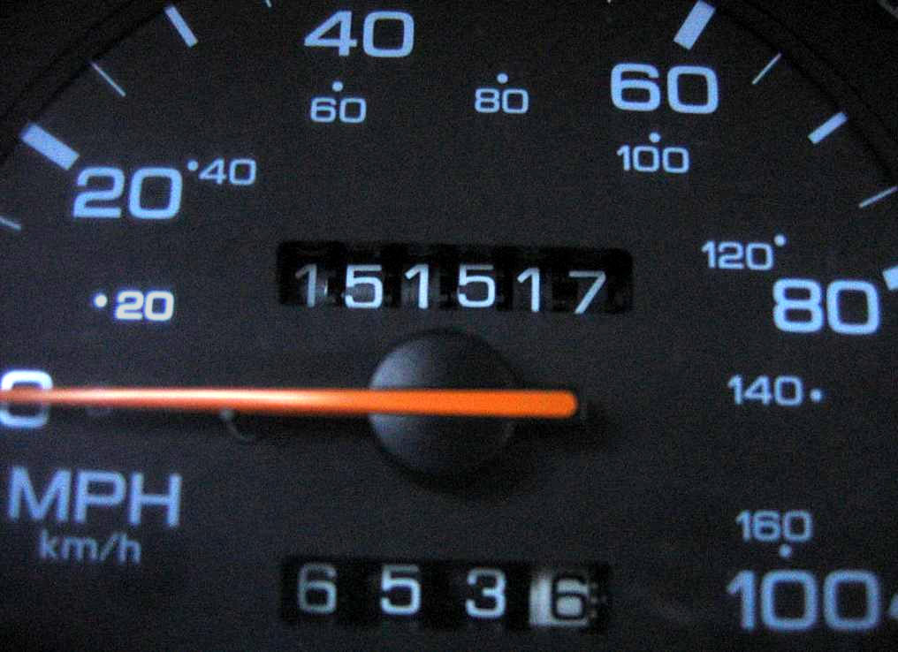

Understanding motion means understanding quantities like position, velocity, and acceleration and how they relate to each other. And it turns out that calculus gives us two incredible tools for understanding these relationships: **derivatives** and **integrals**.

In this lesson you will learn about the **derivative** and what it can tell us about motion. By the end of this lesson you will be able to take a car's *odometery data* (distance traveled) and use it to infer new knowledge about velocity and acceleration.

**2. Accelerometers, Rate Gyros, and Integrals**

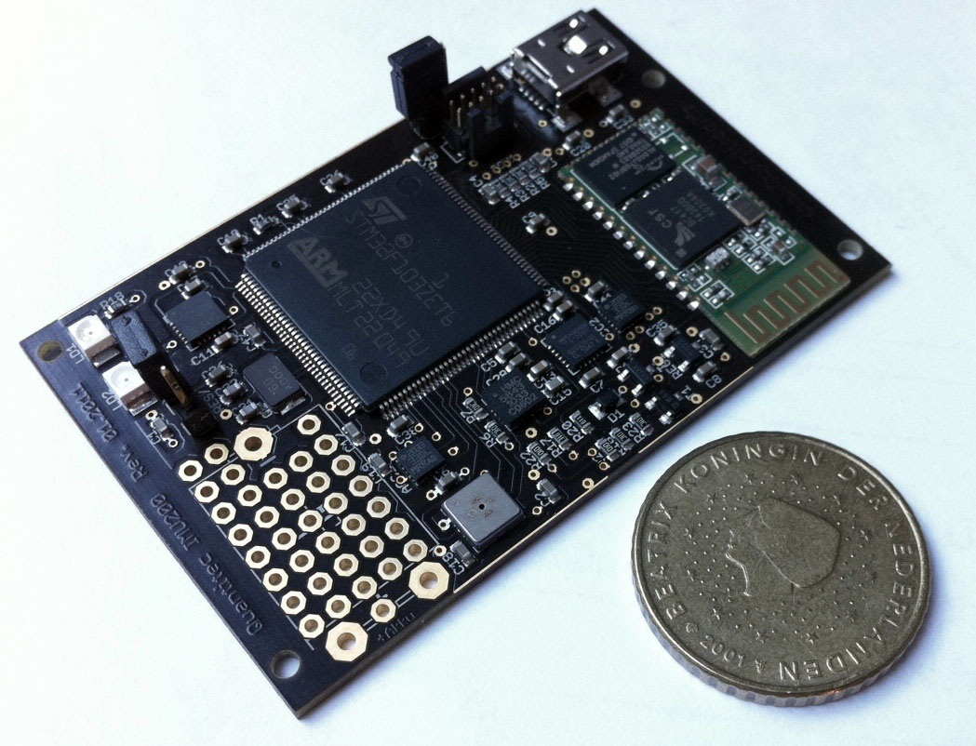

Every self driving car has at least one **inertial measurement unit** in it. These small sensors are able to measure acceleration in three directions as well as rotation rates around all three axes (pitch, roll, and yaw).

But what can we *do* with this data? In this lesson you'll learn how the **integral** can be used to accumulate changes in data (and motion).

**3. Two Dimensional Robot Motion and Trigonometry**

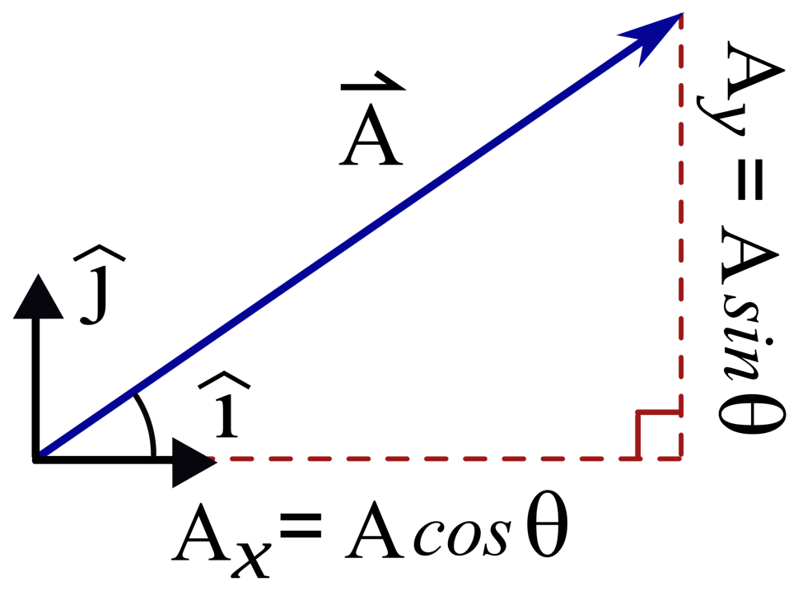

In this lesson you'll use knowledge about a vehicle's **heading** and **displacement** to calculate horizontal and vertical changes in its motion.

**4. LAB - Reconstructing Trajectories**

In the (optional) final project for this course you will use data like this.

| **timestamp** | **displacement** | **yaw_rate** | **acceleration** |
| --- | --- | --- | --- |
| 0.0 | 0 | 0.0 | 0.0 |
| 0.25 | 0.0 | 0.0 | 19.6 |
| 0.5 | 1.225 | 0.0 | 19.6 |
| 0.75 | 3.675 | 0.0 | 19.6 |
| 1.0 | 7.35 | 0.0 | 19.6 |
| 1.25 | 12.25 | 0.0 | 0.0 |
| 1.5 | 17.15 | -2.829 | 0.0 |
| 1.75 | 22.05 | -2.829 | 0.0 |
| 2.0 | 26.95 | -2.829 | 0.0 |
| 2.25 | 31.85 | -2.829 | 0.0 |
| 2.5 | 36.75 | -2.829 | 0.0 |

to reconstruct plots of the vehicle's trajectory like this:

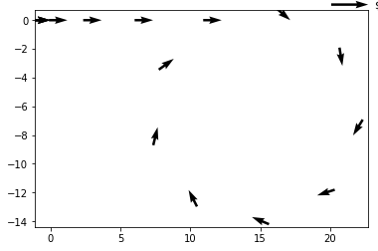

# Navigation Sensors

We will be discussing the following sensors in this course:

* **Odometers** - An odometer measures how far a vehicle has traveled by counting wheel rotations. These are useful for measuring distance traveled (or displacement), but they are susceptible to **bias** (often caused by changing tire diameter). A "trip odometer" is an odometer that can be manually reset by a vehicle's operator.
* **Inertial Measurement Unit** - An Inertial Measurement Unit (or **IMU**) is used to measure a vehicle's heading, rotation rate, and linear acceleration using magnetometers, rate gyros, and accelerometers. We will discuss these sensors more in the next lesson.

To calculate average speed ( v_{\text{avg}}*v*avg​ ), you can use the following equation:

v_{\text{avg}} = \frac{\Delta x}{\Delta t}*v*avg​=Δ*t*Δ*x*​

where \Delta xΔ*x* means "change in position" and \Delta tΔ*t* means "change in time".

#### Trip Data

| **Time** | **Position (in miles)** |
| --- | --- |
| 2:00 | 30 |
| 3:00 | 80 |
|  |  |
|  |  |

### Solution steps

v_{\text{avg}} = \frac{\text{distance traveled}}{\text{time elapsed}}*v*avg​=time elapseddistance traveled​

v_{\text{avg}} = \frac{\Delta x}{\Delta t}*v*avg​=Δ*t*Δ*x*​

v_{\text{avg}} = \frac{x_{\text{final}} - x_{\text{initial}}}{t_{\text{final}} - t_{\text{initial}}}*v*avg​=*t*final​−*t*initial​*x*final​−*x*initial​​

v_{\text{avg}} = \frac{80-30}{3-2}*v*avg​=3−280−30​

v_{\text{avg}} = 50 \text{mph}*v*avg​=50mph

### Trip Data

This data shows information for the same trip that we looked at before. But this time the distance was recorded every twenty minutes.

| **Time** | **Odometer (miles)** |
| --- | --- |
| 2:00 | 30 |
| 2:20 | 40 |
| 2:40 | 68 |
| 3:00 | 80 |
|  |  |

The graph below shows position on the **vertical axis** (in meters) vs time on the **horizontal axis** (in seconds) for a car moving in one dimension in a parking lot. The next few questions refer to this graph.

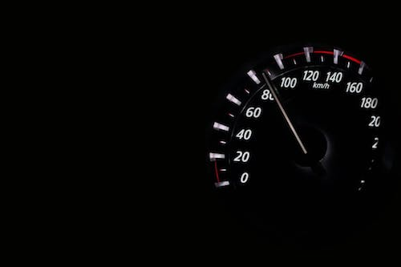

A speedometer measures "instantaneous speed".

1. **Velocity** is the instantaneous rate of change of **position**
2. **Velocity** is the slope of the tangent line of **position**
3. **Velocity** is the **derivative** of **position**

# Differential Notation

\dot{f}(t) = \lim_{\Delta t \to 0} \frac{f(t+\Delta t) - f(t)}{\Delta t}*f*˙​(*t*)=limΔ*t*→0​Δ*tf*(*t*+Δ*t*)−*f*(*t*)​

This "dot" notation is one of two common ways of representing the derivative.

Calculus was simultaneously invented by two people: Gottfried Wilhelm Liebniz and Isaac Newton.

And each came up with his own notation for representing derivatives. The [**Wikipedia article on Notation for Differentiation**](https://en.wikipedia.org/wiki/Notation_for_differentiation) does a good job of explaining them thoroughly but I will summarize here.

### 0. What Newton and Liebniz share (d/dt)

In both notations, \frac{d}{dt}*dtd*​ is an instruction to take the derivative. It means "Take the derivative **with respect to**t*t* of whatever function shows up to the right."

When you see something like this:

\frac{df}{dt}*dtdf*​

You should think "the derivative of some function f*f* with respect to t*t*"

### 1. Liebniz Notation (prime)

If some variable y*y* is a function of x*x* we can write:

y=f(x)*y*=*f*(*x*)

The derivative of y*y* with respect to x*x* is given by:

\frac{dy}{dx} = f '(x)*dxdy*​=*f*′(*x*)

and this could be spoken as "dee y dee x equals f **prime** of x"

We will not be using this notation in this Nanodegree.

### 2. Newton's Notation (dot)

Newton invented Calculus as a tool to help him understand motion. As a result, he was usually thinking of derivatives with respect to ***time*** (not some abstract x*x* variable).

Likewise, his functions weren't abstract f(x)*f*(*x*)'s and g(f(x))*g*(*f*(*x*))'s. The functions he was interested in actually meant something about the physical world! He wanted to describe:

position x(t)*x*(*t*)

velocity v(t)*v*(*t*)

and acceleration a(t)*a*(*t*)

And he wanted to capture the relationships between these quantities compactly. So for Newton: **differentiation with respect to time is indicated by placing a dot over the variable**.

So, for example:

v(t) = \frac{d}{dt}x(t) = \dot{x}(t)*v*(*t*)=*dtd*​*x*(*t*)=*x*˙(*t*)

or for second derivatives:

a(t) = \frac{d}{dt} v(t) = \frac{d}{dt} \dot{x}(t) = \ddot{x}(t)*a*(*t*)=*dtd*​*v*(*t*)=*dtd*​*x*˙(*t*)=*x*¨(*t*)

A second derivative can also be represented as follows:

a(t) = \frac{d^2}{dt^2} x(t) = \frac{d^2x}{dt^2}*a*(*t*)=*dt*2*d*2​*x*(*t*)=*dt*2*d*2*x*​

# A "Typical" Calculus Problem

If you’ve taken calculus before you probably have vague recollections of terms like “the chain rule” or “the product rule” or “the quotient rule”... these are all techniques for calculating the derivative of a function when you know the function’s algebraic form. Calculating the derivative of a function is also known as differentiation. And in a typical calculus class you would spend a LOT of time learning how to differentiate various functions…

Below you will see a differentiation problem that is similar to what you might find in a typical calculus class. Read through this problem and think about what it’s asking. Afterwards I’m going to explain why we are **not** going to spend time solving these kinds of problems in this course.

### Differentiation Example Problem

1. A self driving car's position is described as a function of time from t=0*t*=0 to t=10*t*=10 by the following equation:

x(t) = -t^2 + 10t + 5*x*(*t*)=−*t*2+10*t*+5

What is the derivative, \dot{x}(t)*x*˙(*t*) of this function? A graph of x(t)*x*(*t*) is included below.

# How Odometers Work

A mechanical odometer works by coupling the rotation of a vehicle's wheels to the rotation of numbers on a gauge like this:

Each of these numbers is written on a dial which has the numbers 0 - 9 written on it.

But that last digit on the gauge needs to rotate **very slowly** compared to the rotation rate of the vehicle's tires. Typically, a car's wheels will have to complete **750** rotations to move 1 mile. And since there are 10 digits on each dial, that means the last digit should only complete one rotation after the wheels have completed **7,500** rotations!

We can even express this mathematically:

\frac{\Delta \theta_\text{odometer}}{\Delta \theta_\text{tires}} = \frac{1}{7,500}Δ*θ*tires​Δ*θ*odometer​​=7,5001​

This reduction of rotation rate is accomplished through gear reduction. If you look at the blue and green gears in the image below you should get a sense for how that works.

You don't need to remember any of this. Digital odometers don't even work this way (though they are pretty cool too).

I just think animations of gears are too fun to pass up!

# Position, Velocity, and Acceleration

Allow me to say the same thing about **position** and **velocity** in 5 different ways.

1. **Velocity** is the derivative of **position**.
2. **Velocity** is the instantaneous rate of change of ***position*** with respect to ***time***.
3. An object's **velocity** tells us how much it's **position** will change when time changes.
4. **Velocity** at some time is just the slope of a line tangent to a graph of **position** vs. **time**
5. v(t) = \frac{dx}{dt} = \dot{x}(t)*v*(*t*)=*dtdx*​=*x*˙(*t*)

It turns out you can say the same 5 things about **velocity** and **acceleration**.

1. **Acceleration** is the derivative of **velocity**.
2. **Acceleration** is the instantaneous rate of change of ***velocity*** with respect to ***time***.
3. An object's **acceleration** tells us how much it's **velocity** will change when time changes.
4. **Acceleration** at some time is just the slope of a line tangent to a graph of **velocity** vs. **time**
5. a(t) = \frac{dv}{dt} = \dot{v}(t)*a*(*t*)=*dtdv*​=*v*˙(*t*)

We can also make a couple interesting statements about the relationship between **position** and **acceleration**:

1. **Acceleration** is the second derivative of **position**.
2. a(t) = \frac{d^2}{dt^2}x(t) = \frac{d^2x}{dt^2} = \ddot{x}(t)*a*(*t*)=*dt*2*d*2​*x*(*t*)=*dt*2*d*2*x*​=*x*¨(*t*)

We'll explore this more in the next lesson. For now, just know that differentiating position twice gives acceleration!